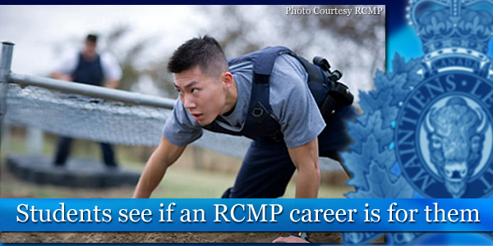Interested in

POLICING?

The RCMP is offering a “**Police Youth Academy**” for   
**grade 11** and **12 students** from **April 12-20, 2017,** inclusive.

This program is designed to place the students in a **simulated RCMP training environment** as well as **role-playing** the realities of policing. The students that successfully complete each phase of the selection process will attend the Academy and experience a variety of activities that an RCMP Cadet would experience but in a condensed format.

Students will receive **instruction and lectures on law, social and communications skills, physical training** as well as some **police tactics** and **self-defense** and a variety of other topics. They will be involved in a great deal of role-playing scenarios where they will take on the role of a police officer. They will be required to **work in a team** and participate in all the planned activities.

Application packages can be picked up from:  
**Ms. Chittenden or   
the Career Resource Room (213)** or printed off from the career site. SINGLE SIDED Read Instructions carefully.

Applications are due back to Ms. Chittenden no later than:  
**Wed. November 30th**